**Name: Mriganka Patra**

**Email:** [**mriganka.patra@cognizant.com**](mailto:mriganka.patra@cognizant.com)

**Emp ID: 2415820**

**Day 18**

**Sprint 1 Submission**

Task 1.1: As an admin I want to define record types for Accounts based on regions so that data can be segmented accordingly.

a. Go to Setup >

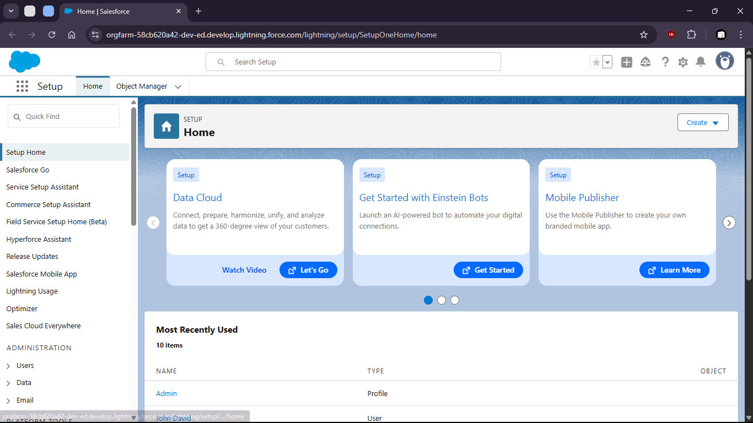

b. go to Object Manager

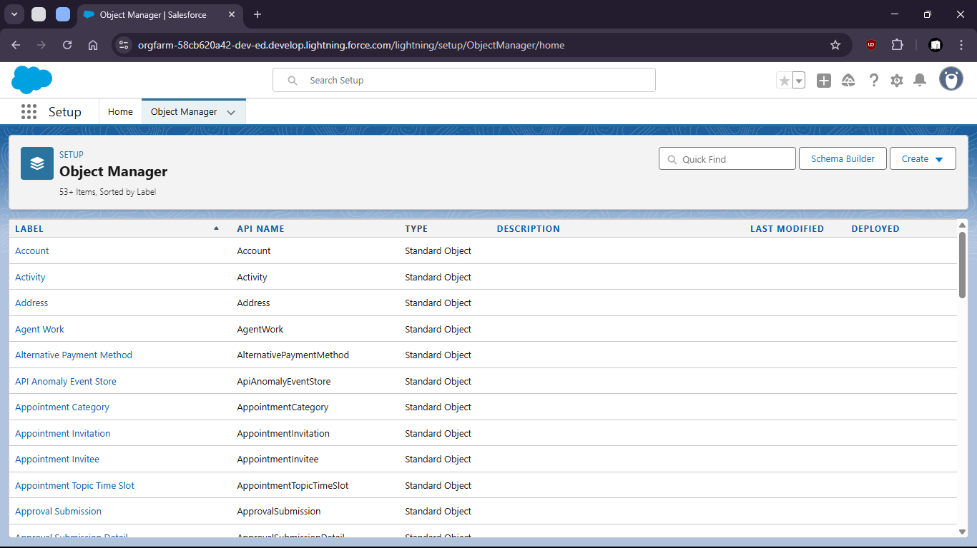

c. Select Account object

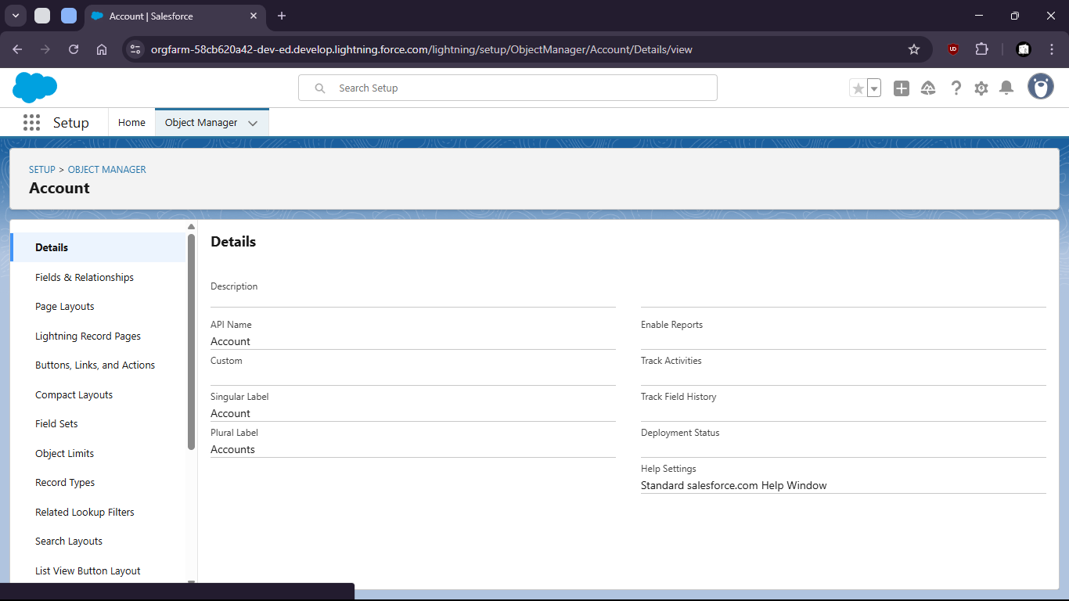

d. select Record Types

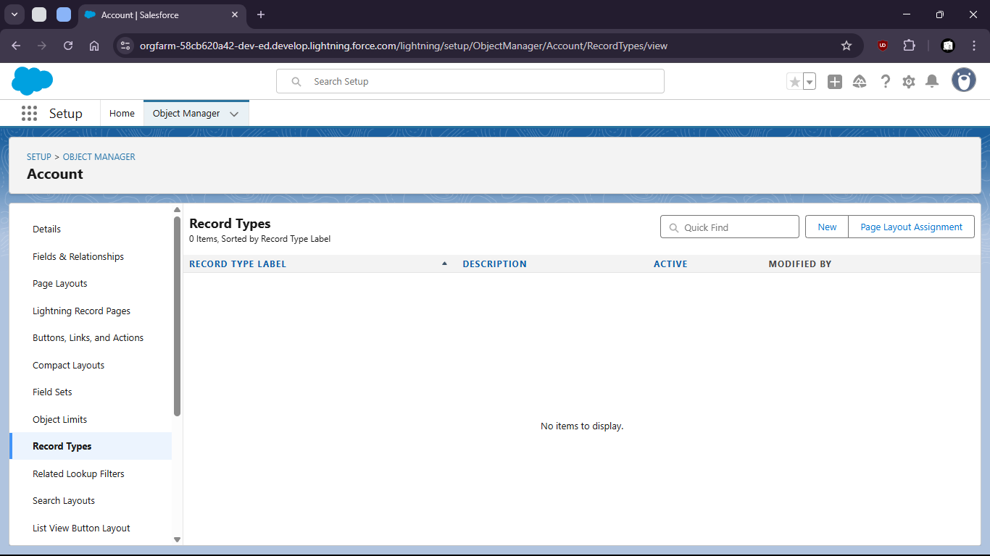

e. create new Record Type for Kolkata people and give permission to admin

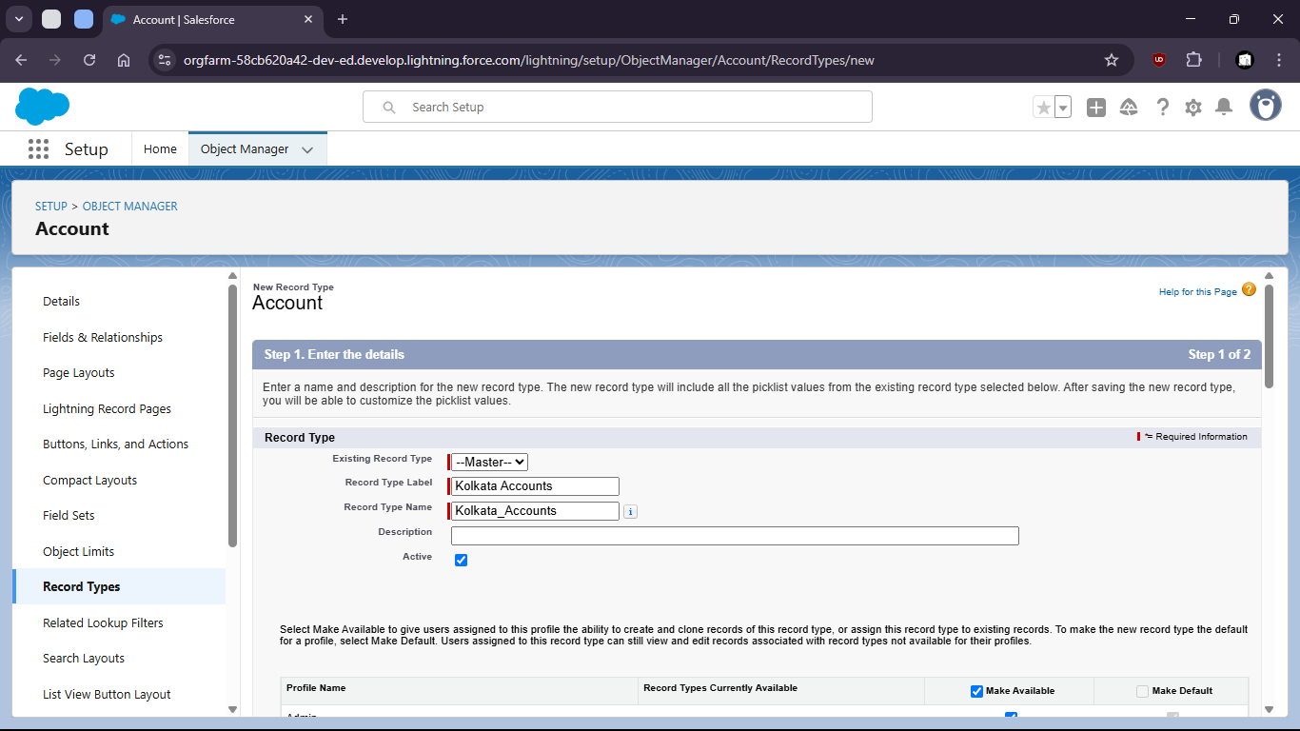

f. give permission

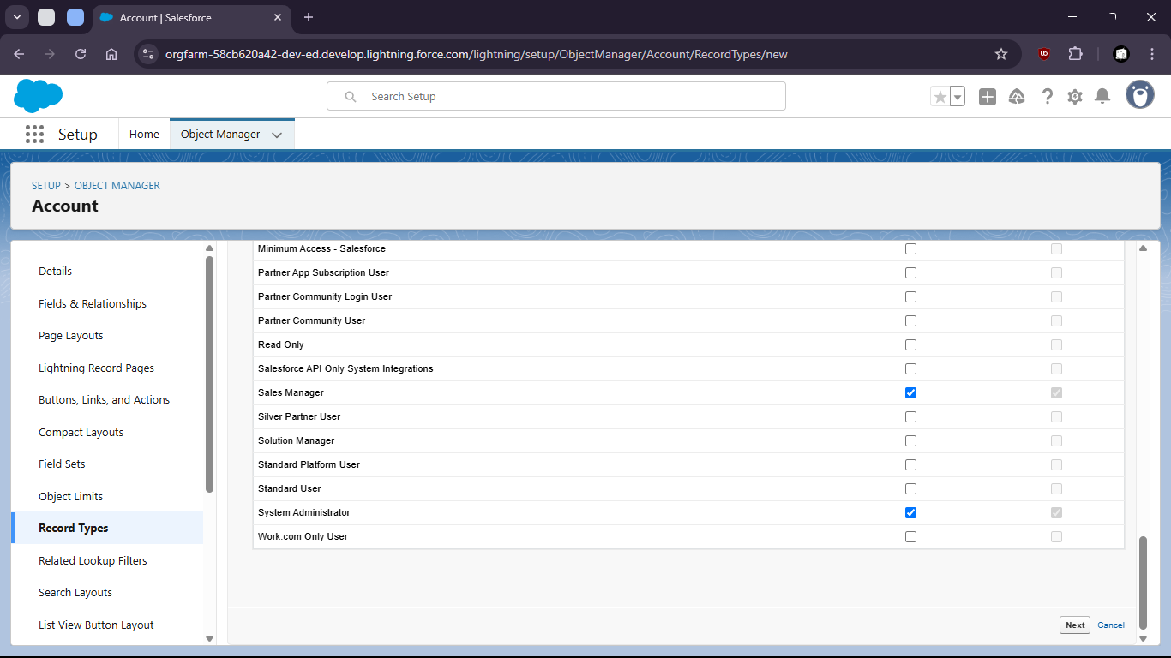

g. set page layout

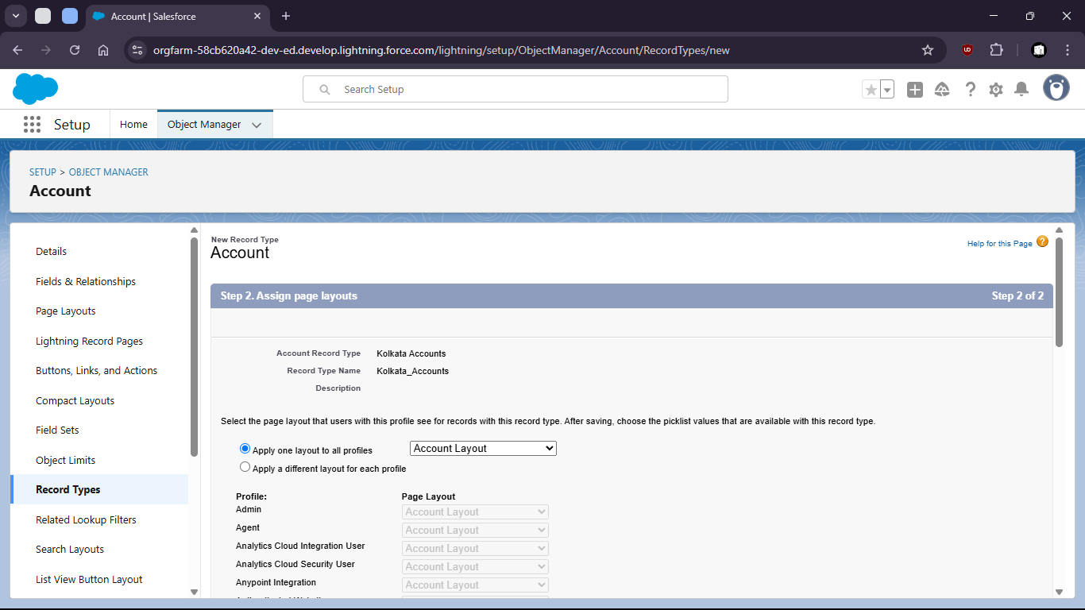

h. Select save and new

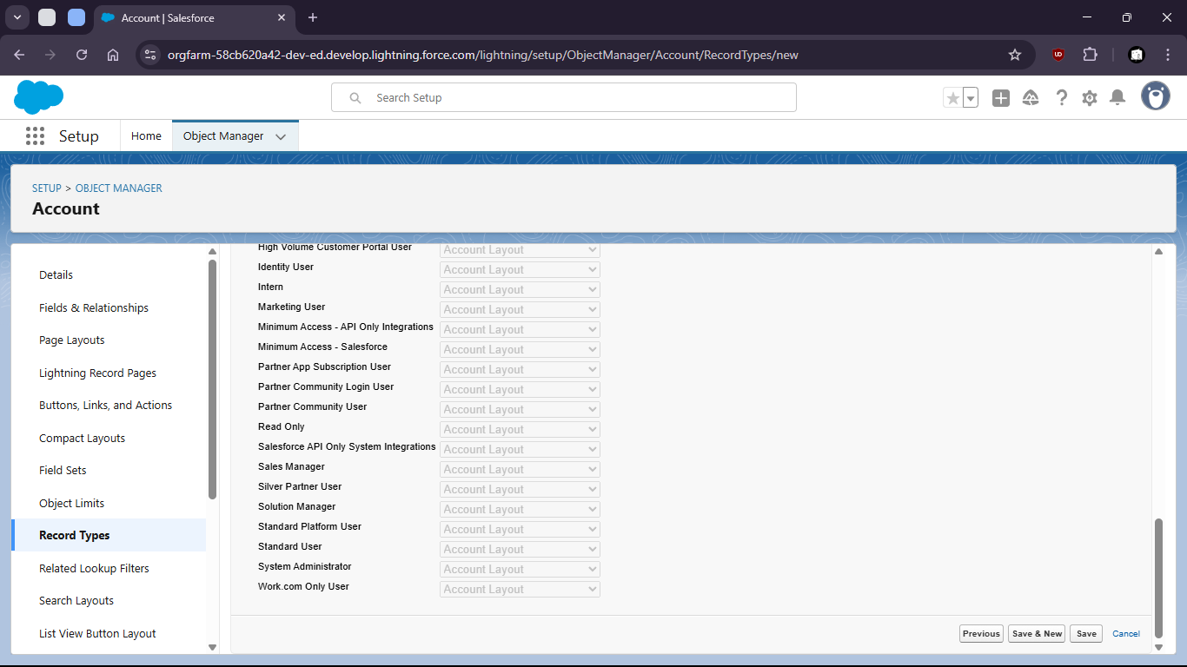

i. create another for Delhi region

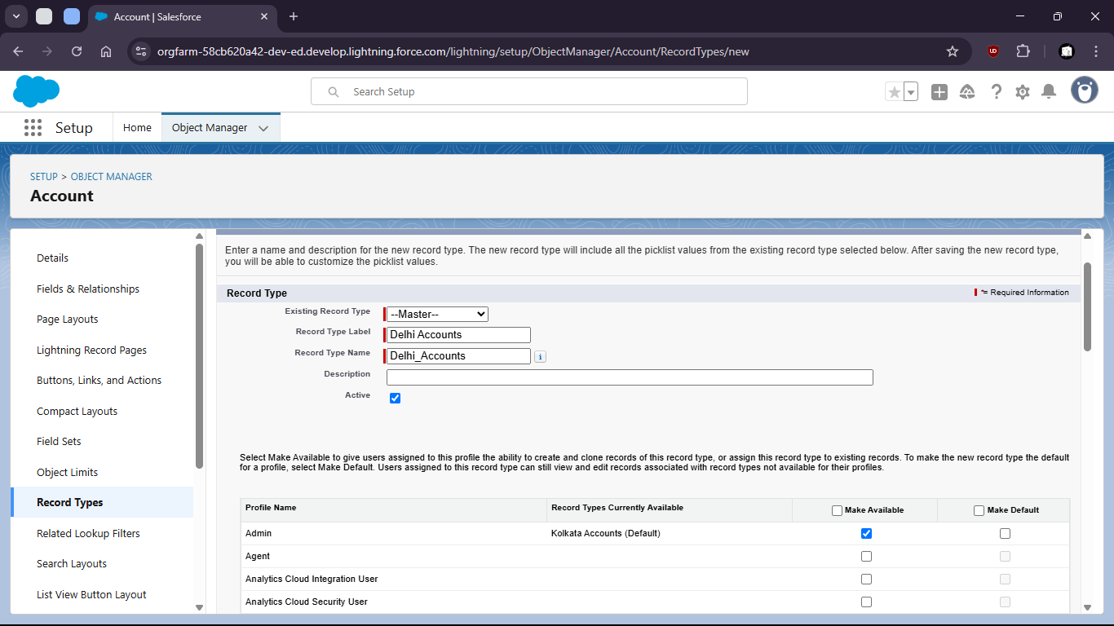

j. Give permissions to profiles

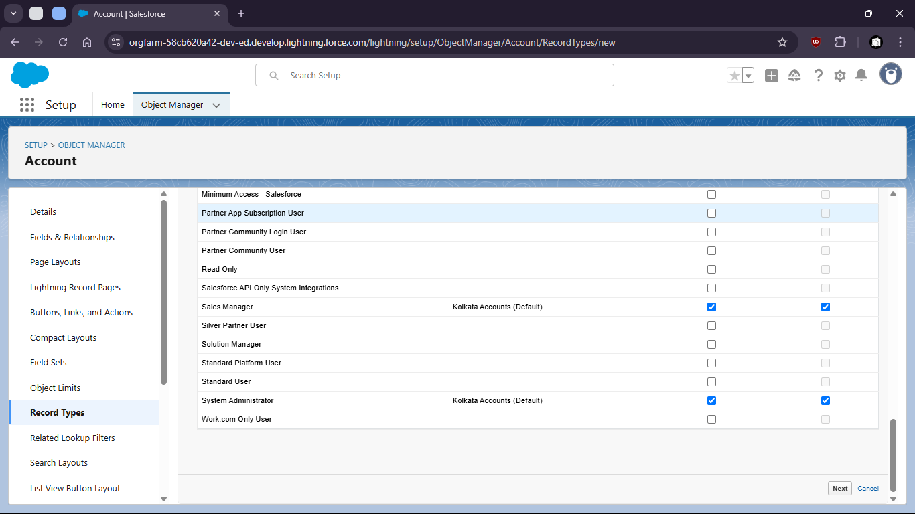

k. Set layout

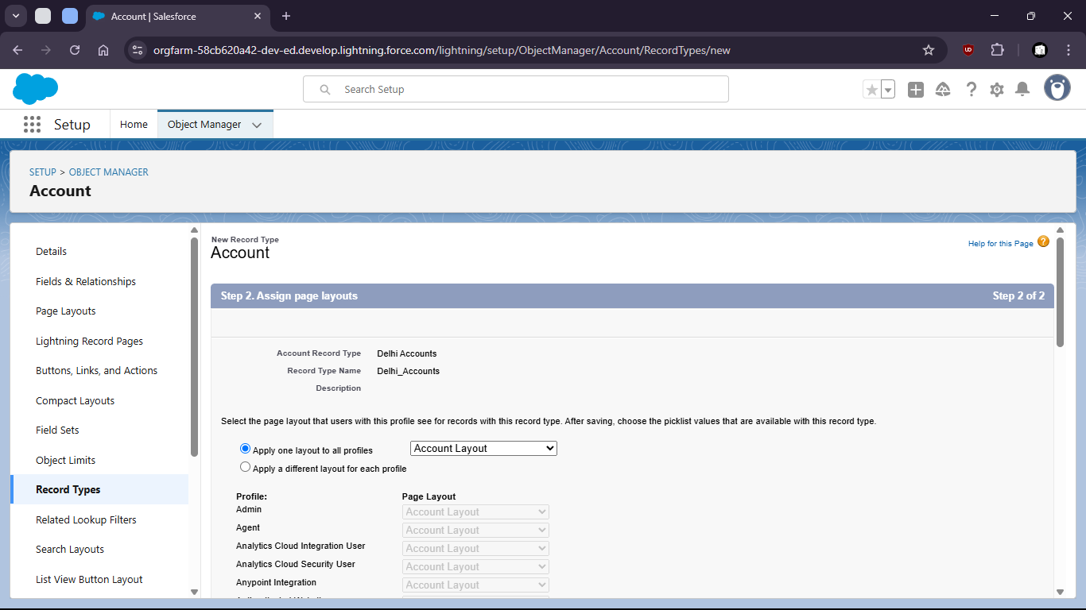

l. Save



